Southern Horsemen’s Organization, Inc.
Speed Event
Pattern Book

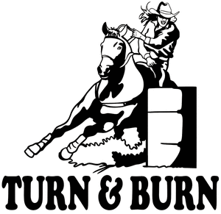

Stake Race

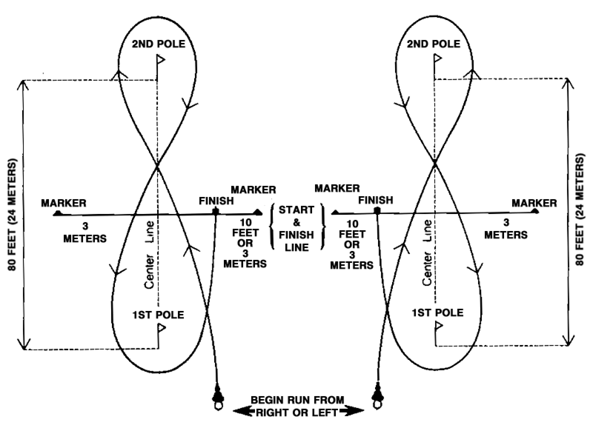

Quads

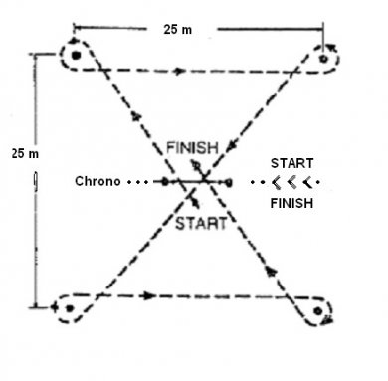
Pattern can be ran to the left or right first starting with the far end poles

Pole Bending
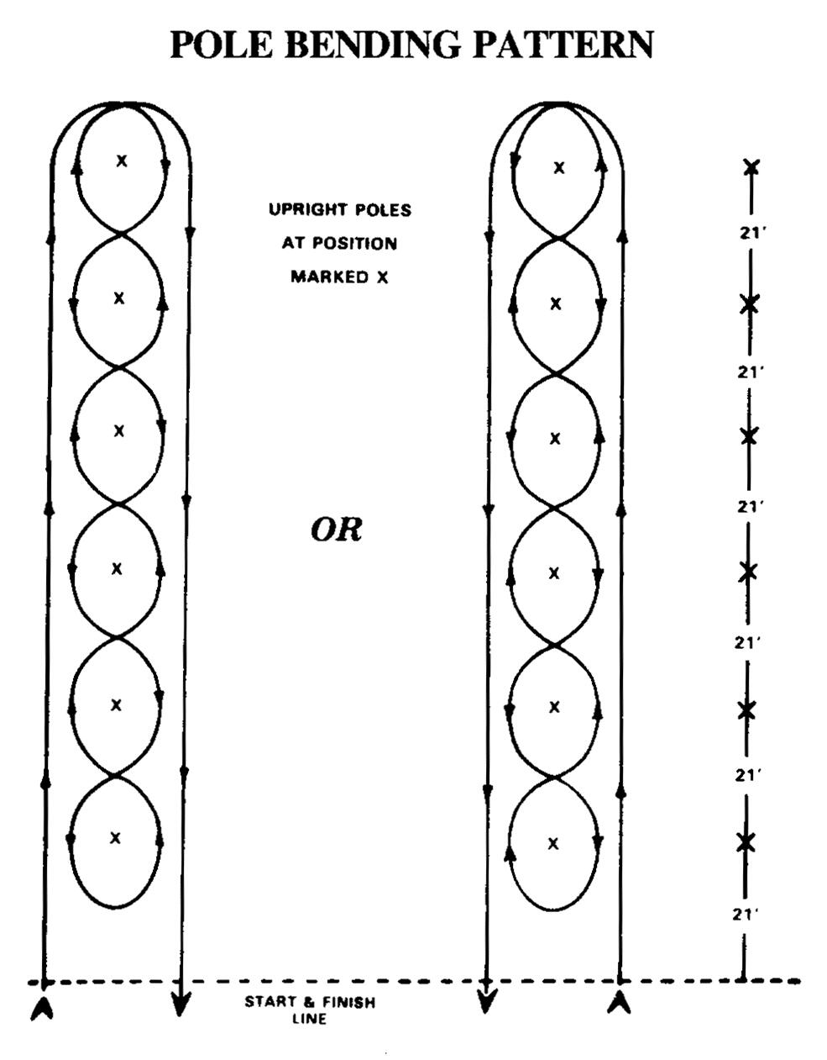

Barrel Racing

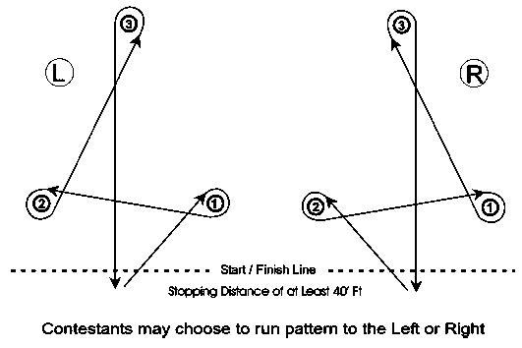

Straight- Away Barrels

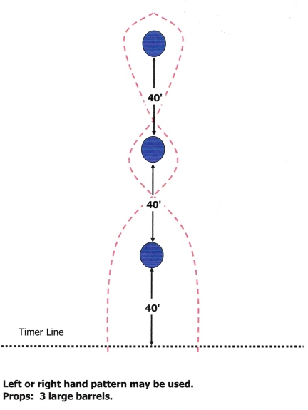

Arena Race

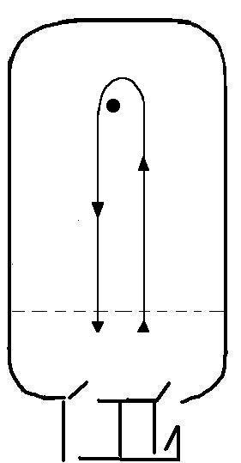

Pattern can be ran by making
a left or right hand turn.

